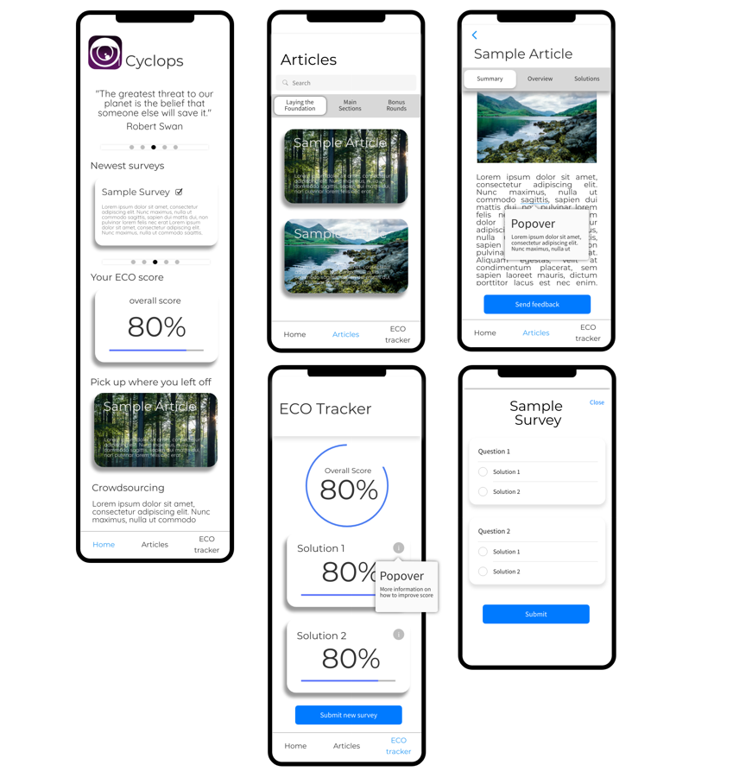

Next goal: Build a static App.

The App should have all functionality as image shown. Except the last page (Sample Survey)

User should able to redirect to other page for some pages. i.e. page2 redirect to page 3.

When you select a page, you will only be responsible for this page in the later development

Page1:

The “Pick up where you left off” part. According to out knowledge, it hard to achieve this. We temporarily replace this function with “Newest article” as picture below:

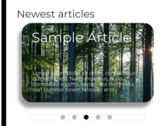

So, in this page, there is 3 redirections:

“Newest Survey” section to Survey page (not need now, but need in future)

“Your ECO score” section to ECO page (page 4)

“Newest Article” section to article page (page 3)

Page2:

In this page, there is 1 redirection:

“Article” section to Article page (page 4)

And utilize the search bar.

Page3:

In this page, Utilize the Popover.

Also, using the “reactive form” (Angular tutorial week3) to utilize send feedback

Page4:

This page is simple for now, but you have to response the later development on calculates the score and implement user’s solutions.